# DIY Capacitor Project

## Objective

The goal of this project is to gain a solid understanding of how capacitors are constructed and how their capacitance is calculated. Additionally, the time varying nature of capacitors’ charge and discharge times is explored.

## Theory Overview

### Capacitor Construction

Capacitors are usually made of two conductive plates in parallel, separated by a thin non-conductive material called a dielectric. The capacitance of a capacitor is directly proportional to the surface area of the conductive plates and the permittivity (or dielectric constant which is a measure of goodness or effectiveness) of the dielectric. The capacitance, on the other hand, is inversely proportional to the distance between the conductive plates; this distance is usually equal to the thickness of the dielectric material.

In the first part of this project, we will attempt to build a capacitor out of aluminum foil and saran wrap. In the second part, we will try to determine the “actual” capacitance of our capacitor by measuring the charge/discharge time.

### Charge/Discharge Time of an RC Circuit

A capacitor is a passive device for storing electric charge. When an electric source like a battery is connected to a capacitor, the battery induces a current in the circuit which moves electrons from one of the capacitor’s plates to the other. As the charge builds up on the capacitor’s plates, the voltage across the capacitor increases until it reaches that of the battery. At that point the current and movement of charges stop.

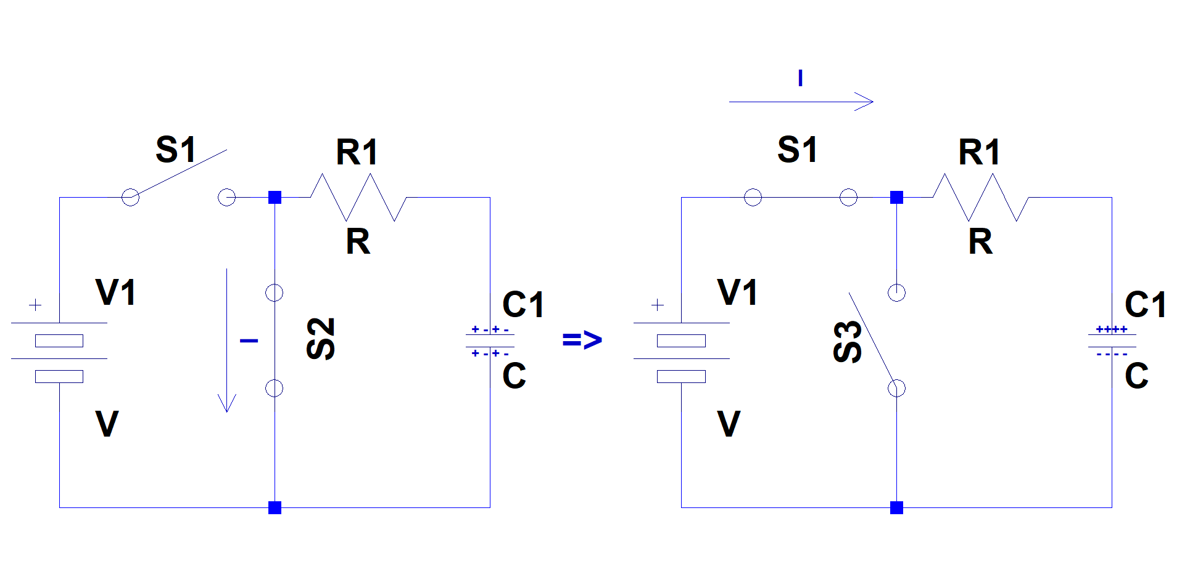

As one can imagine, the current at the moment a battery is attached to a capacitor is the largest, and as the capacitor collects more charge, the current slows down. Eventually, once the capacitor reaches its full charge, the current comes to a stop.

The charge and voltage build up across the capacitor follow a similar profile. At time 0, the charge, and therefore the voltage, across the capacitor are 0. The charge, and therefore the voltage, builds up quickly at the beginning, but as the capacitor reaches its maximum charge, the charge build-up slows down.

The time it takes to charge a capacitor is a function of how large the capacitor is (its capacitance) and how large the resistance is between the battery and the capacitor. The chart below displays the charge time of a capacitor as a function of multiples of RC.



A capacitor charges to ~63% of the input voltage after a time t63% = 1RC. It charges to ~95% of the input voltage after a time t95% = 3RC. It follows a similar profile when discharging. In other words, a capacitor discharging through a resistor loses ~63% of its charge in a time t63% = 1RC and ~95% if its charge in a time t95% = 3RC.

Electrical engineers use these time constants to design RC circuits that produce very specific time durations. In the next section we learn about one such circuit.

## Procedure

Part 1: Building a Capacitor

Material needed:

* Aluminum foil
* Saran Wrap (Polyethylene)
* Paper tubes
* Scotch tape
* Painters blue tape
* Two wire clips

Steps:

* Markings:
  + Take one paper tube and draw a straight line along its length  
      
    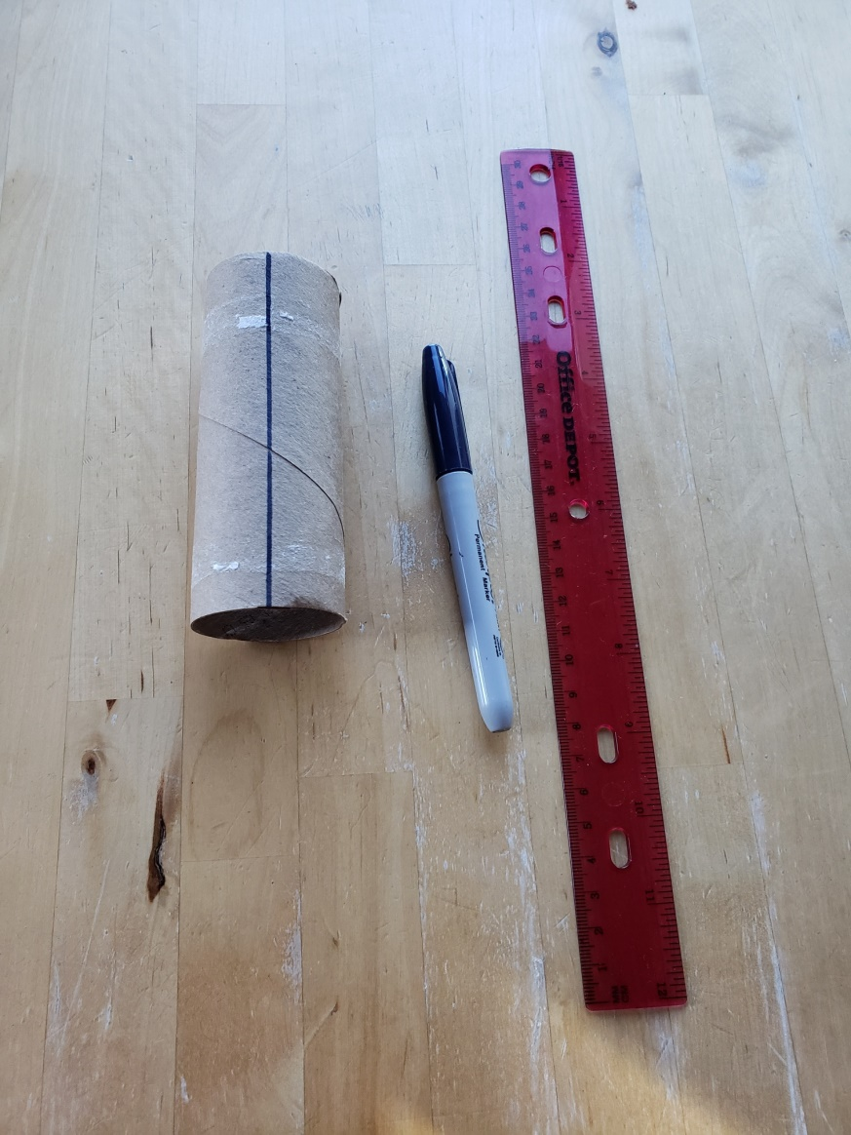
  + Place a piece of blue tape along the short edge of your table. The length of the tape should be approximately the same length of your paper tube.  
      
    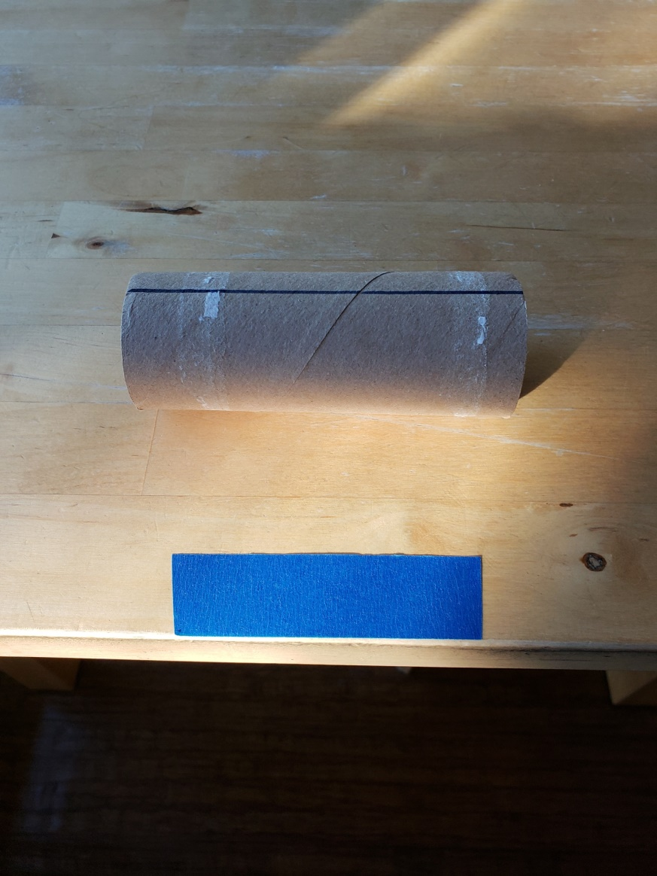
  + Align the straight line on your tube to the edge of the blue tape (the edge farther away from the edge of the table. Roll the tube away from the edge of the table for 4 complete turns. (You should observe the straight line making one complete rotation four times.)
  + Mark that spot on the table with another piece of blue tape.  
      
    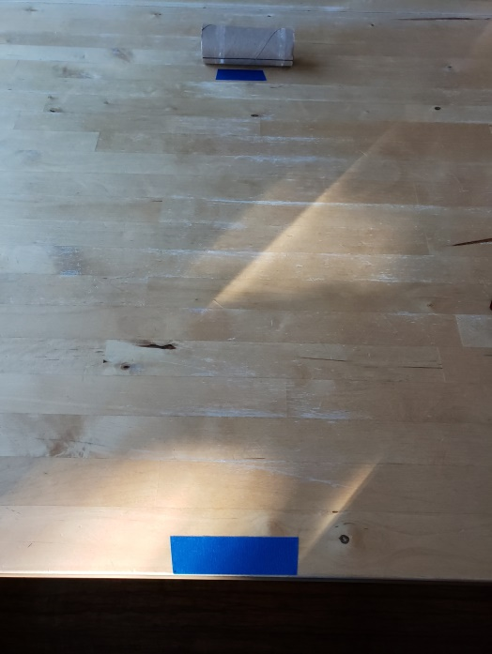
  + Measure the distance between the two tapes. You will use this to determine the surface area of the conductive plates.
* Layering:
  + Place one layer of saran wrap on the table. Make sure the end at the edge of the table is wrapped slightly under the table; this way it will not move while you are putting the other layers on. The other end should be cut past the second blue tape on the table.  
      
    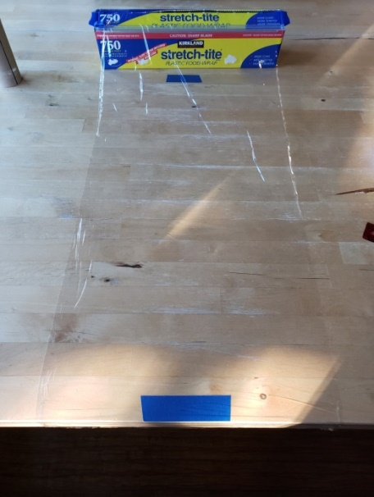
  + Place a layer of aluminum foil over the layer of saran wrap. The two edges of the foil should line up with the “inner” edges of the blue tapes on the table. See the picture below. (This way, we are ensuring that the length of the foil is sufficient to go around the tube 4 times.)  
      
    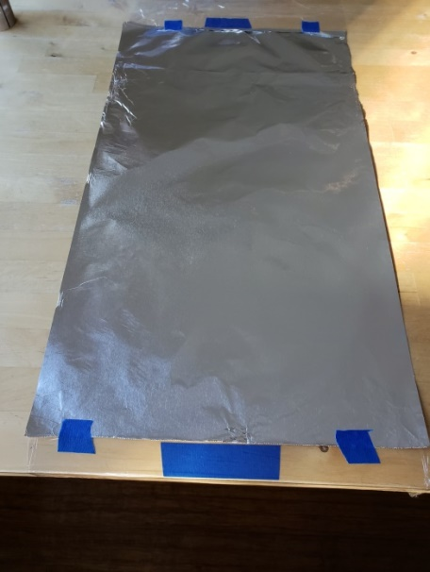
  + Measure the width of the aluminum foil.
  + Tape the edges of the foil to the saran wrap underneath it.
  + Cut a narrow strip of aluminum foil and tape it to the bottom left edge of the foil you just put down. (*This will be used as one of the leads of the capacitor.*)  
      
    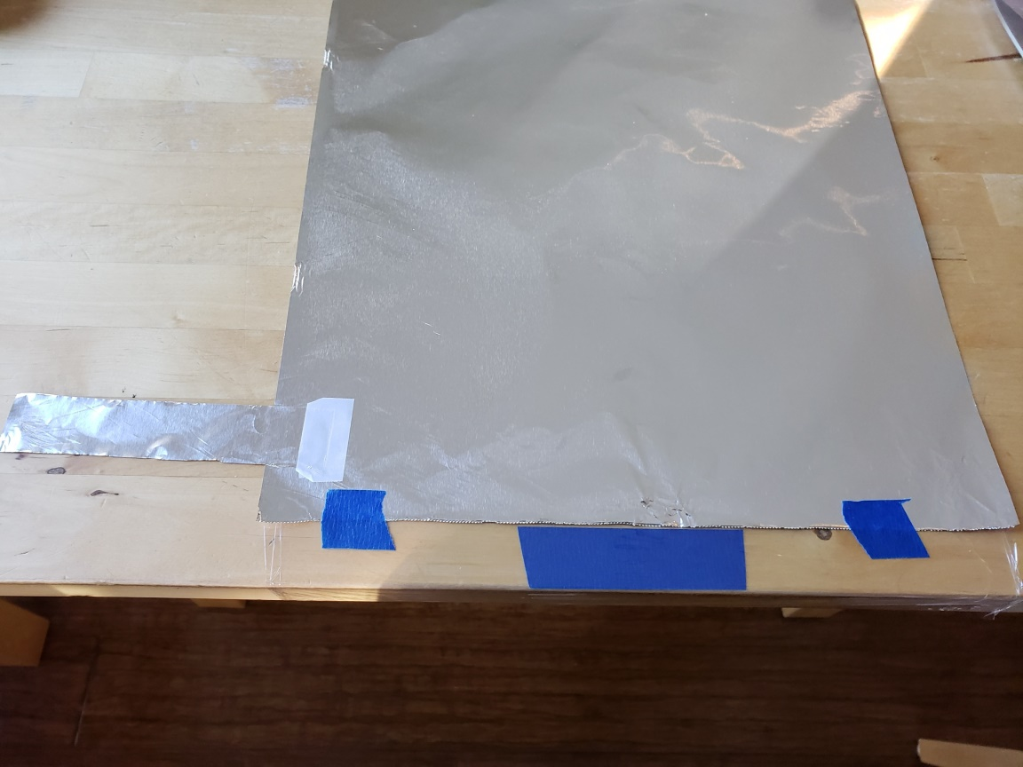
  + Fold the strip back on itself and tape it again. (*This strengthens the “lead”*.)  
      
    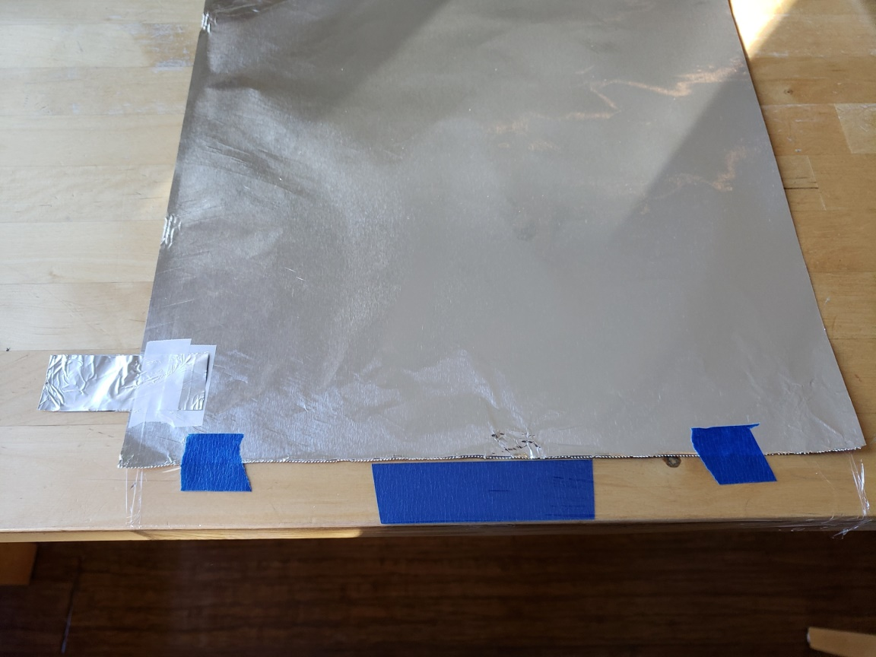
  + Place a second layer of saran wrap over the first layer of foil.
  + Place a second layer of aluminum foil over the second layer of saran wrap. Similar to the first layer of foil, make sure the second layer is placed between the “inner” edges of the blue tapes on the table, and tape the edges of the foil to the saran wrap underneath it.
  + Cut a second strip of foil and tape it to the lower right edge of the second foil.  
      
    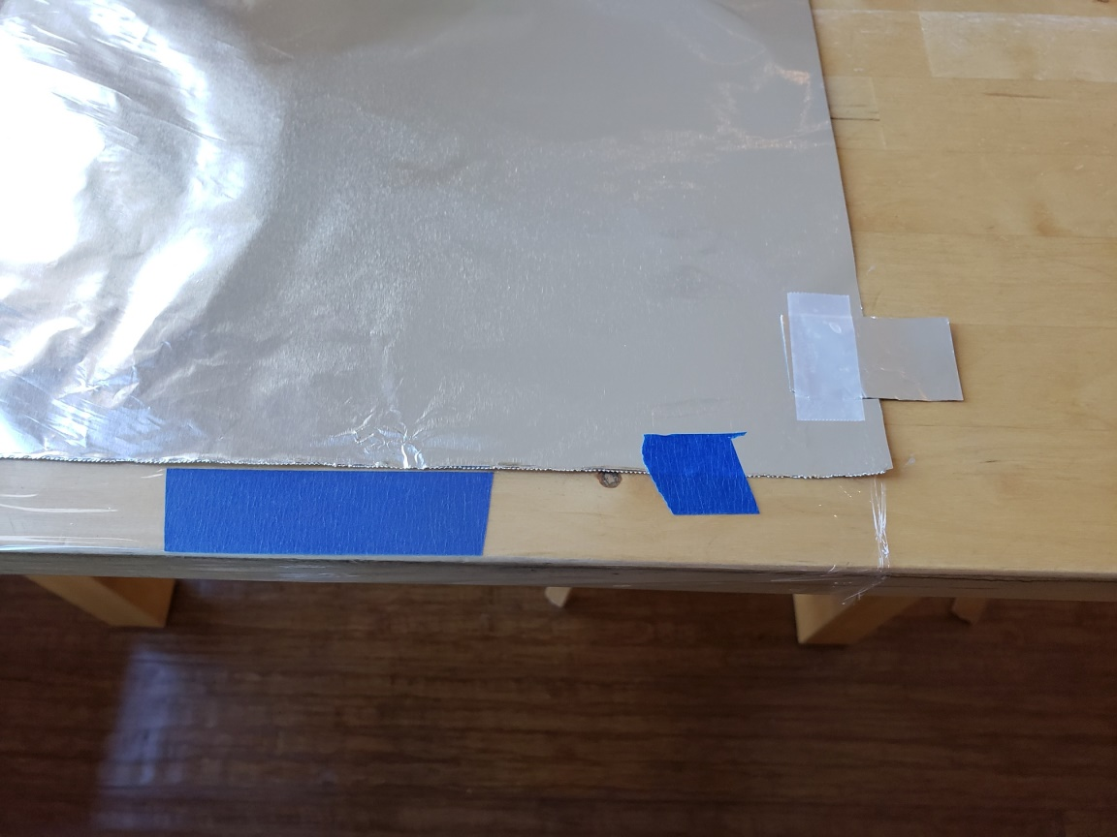
* Final construction:
  + Using a glue stick, spread some glue on the surface of the second aluminum foil. Make sure your partner is holding the foil-saran wrap layers firmly down on the table so that they don’t bunch up during this step.
  + Place your paper tube on the lower edge of the foil-saran wrap layers. Unfold the saran wrap under the table and roll over the tube.
  + Roll the tube carefully towards the upper edge of the layers. (Again, make sure your partner is holding the upper edge of the layers firmly in place.)
  + Once the layers are completely rolled up, tape the final edge down.
* Calculate the capacitance:
  + Calculate the surface area of the conductive layers (aluminum foil)
  + Measure the thickness of the saran wrap using a caliper
  + Below is a table of relative permittivity values. Relative permittivity is the ratio of the material’s permittivity to that of vacuum   
      
    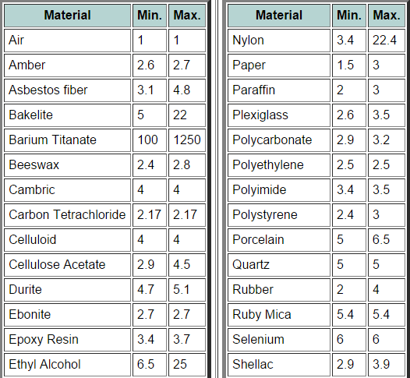  
      
    Calculate the permittivity of saran wrap (made of Polyethylene)
  + Calculate the capacitance. (Remember to account for the number of overlapping sections, , of the conductive plates.)

Part 2: Measuring the Capacitance

* Build the following circuit using your DIY capacitor  
    
  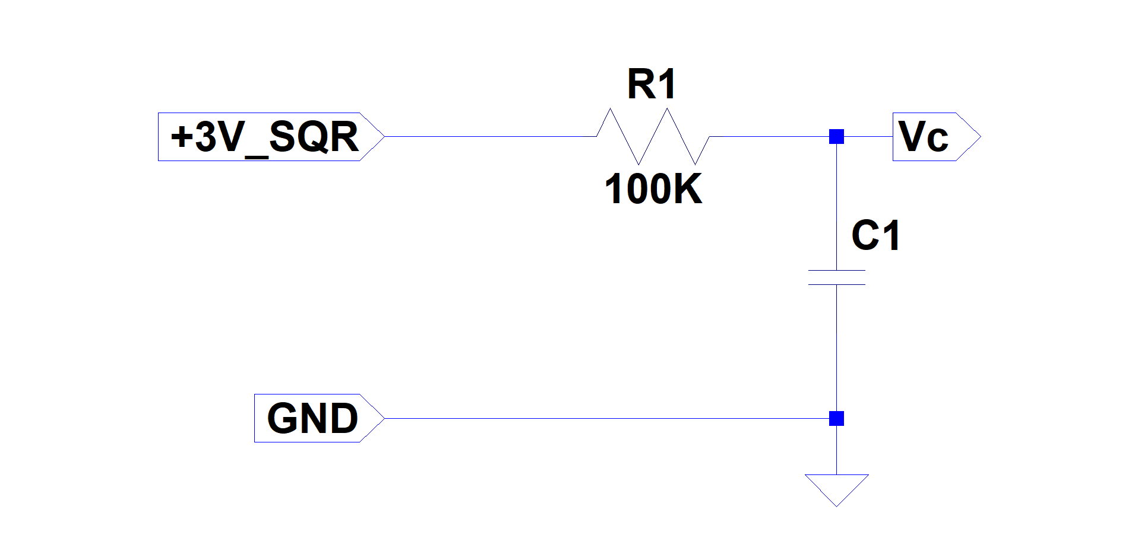
* Set your function generator to output a square wave with amplitude of 3V and offset of 1.5V.
* Connect the output of the function generator to the input of your circuit.
* Connect your scope probe to Vc.
* Adjust the function generator’s frequency until you can clearly observe the charge time of the capacitor on the scope. (See the example below.)  
    
  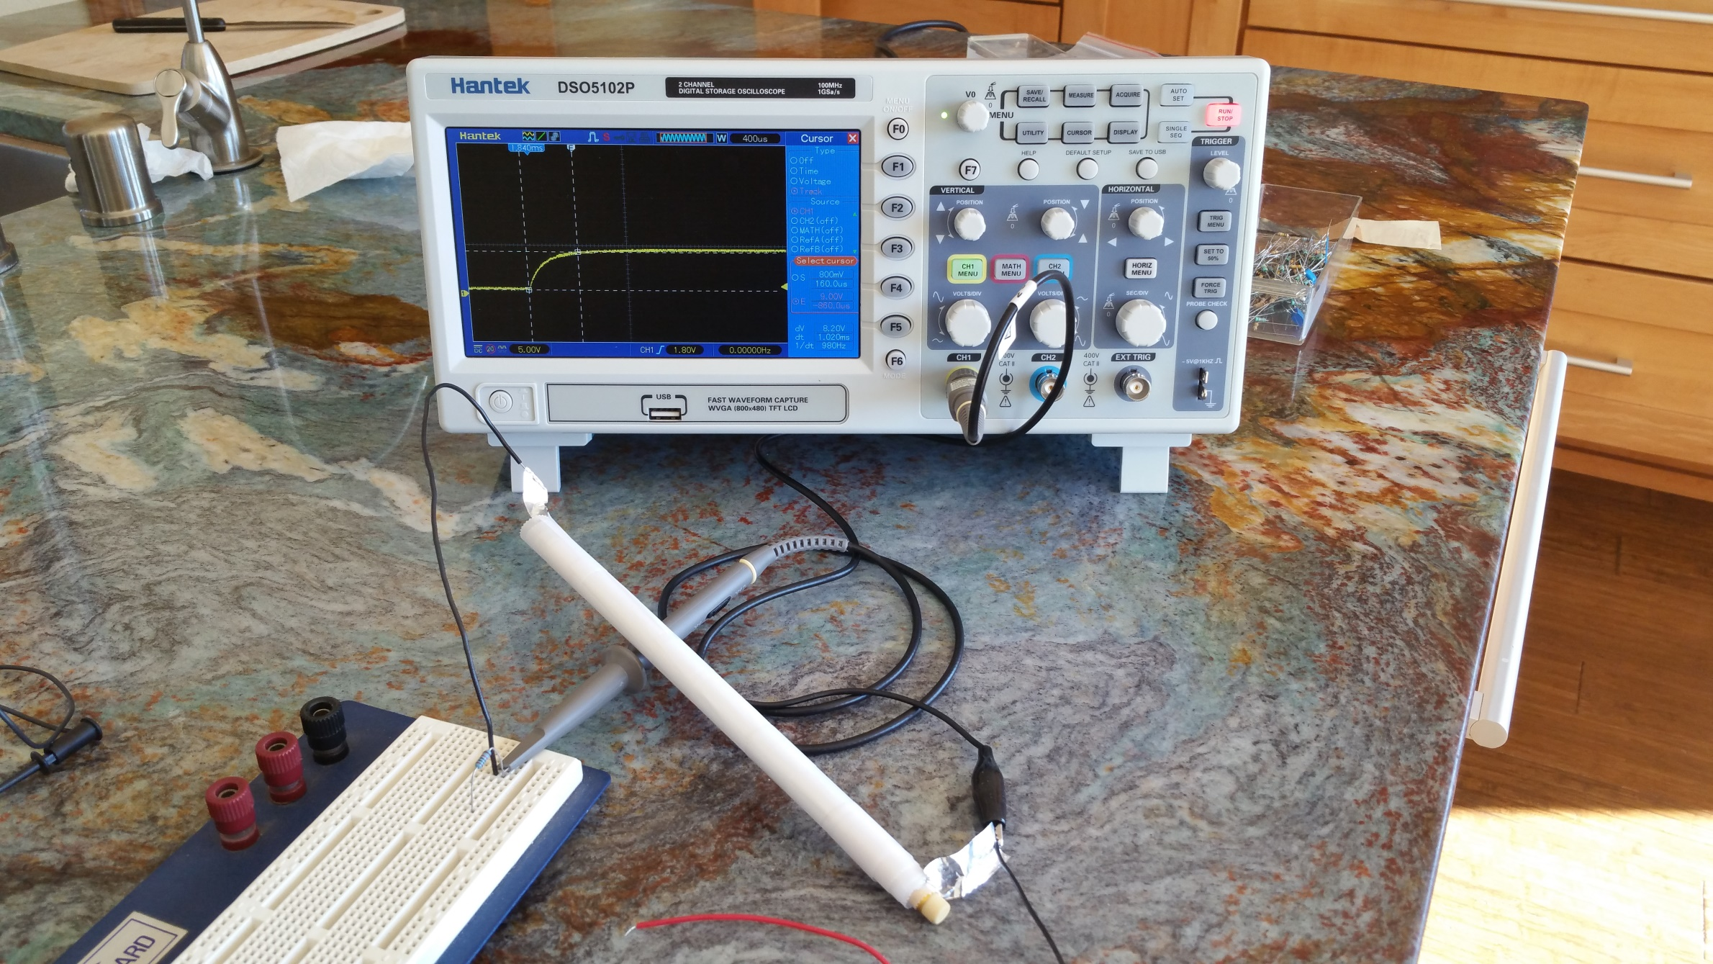
* Measure the charge time from 0V to 95% of the input voltage
* We know that the time it takes to charge a capacitor to 95% of the input value is equal to . Determine the value of your capacitor
* How does this value agree with the value you calculated for the capacitance in Part 1?